**Skill Group & Service Configuration**

The below describes the process of configuring a Skill Group and Service in ICM for a Skill\VDN created in the PBX.

**Creating\Configuring Skill Group**

* Open **Configuration Manager**.
* Open **Skill Group Explorer** as shown below.

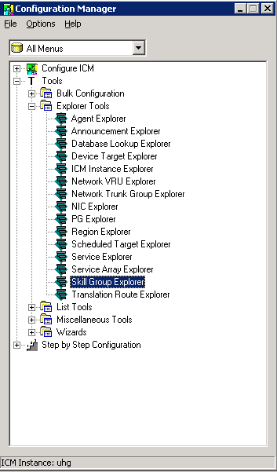

* Browse to the **Peripheral** you are creating the Skill Group on and select **Retrieve**.

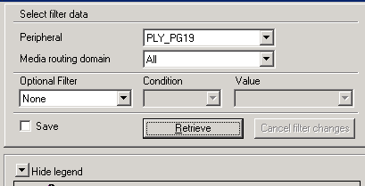

* To add a new Skill Group click **Add Skill Group** at the bottom of the window.

Wor153

* The following window appears on the right hand side.

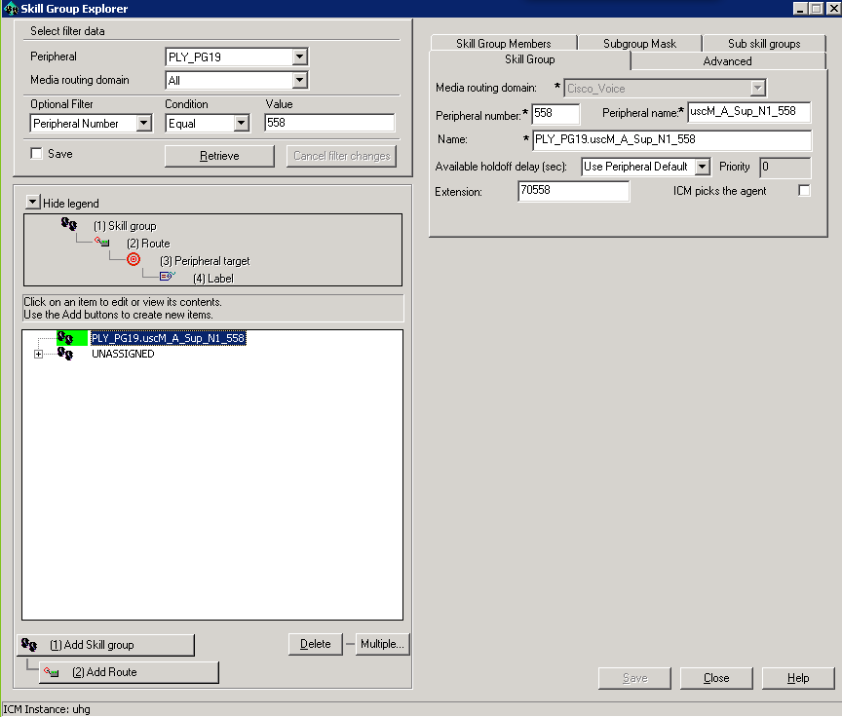

* Fill in the details on the **Skill Group** tab and also as shown below on the **Subgroup Mask** tab.

***Note:*** Fields that need to be filled in are:

-On Skill Group tab:

***-Peripheral Number:*** This is the Skill number you created.

***-Peripheral Name:*** This is a name you specify, usually contains the Skill number.

***-Extension:*** This is the extension for the Skill, this usually is a 70 entered in front of the Skill number as shown above. The case of Node 11 a further 30 is put in front of the Skill.

-On Subgroup Mask tab:

***-***All checkboxes up to 8 are checked as shown below.

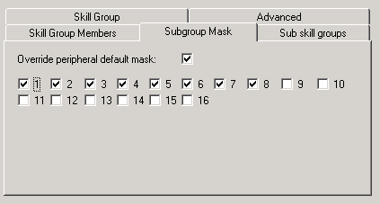

* Select **Save**, you Skill Group has now been created in ICM.

**Creating\Configuring Service**

* Open **Service Explorer** as shown below.

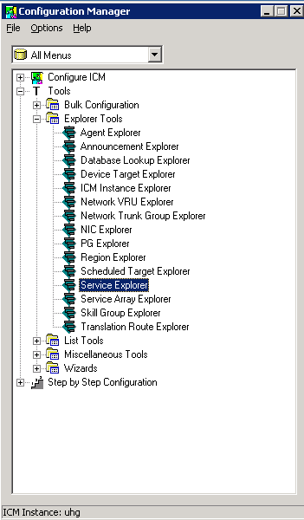

* Select **Add Service** at the bottom of the window.

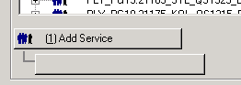

* The following window appears on the right hand side.
* Fill in the appropriate details.

***Note:*** Fields that need to be filled in are:

-Under Service tab:

***-Peripheral Number:*** This is the VDN number you created.

***-Peripheral Name:*** This is a name you specify, usually contains the Skill and VDN number.

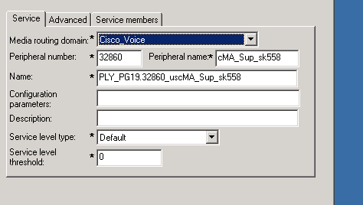

-Under Advanced tab:

***-Extension:*** Specify the VDN number here.

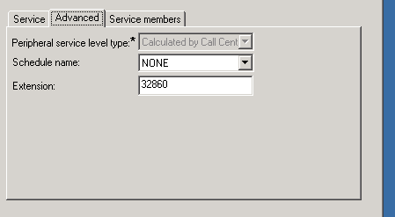

-Under Service Members tab:

***-*** Select Add here and browse through the list to the Skill Group name you specified when you created the Skill Group previously.

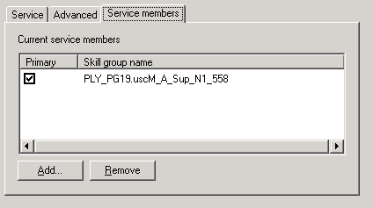

* Next Add **Route**, **Peripheral Target** & **Label**. Details are shown below. Highlighted are the fields that need to be populated.

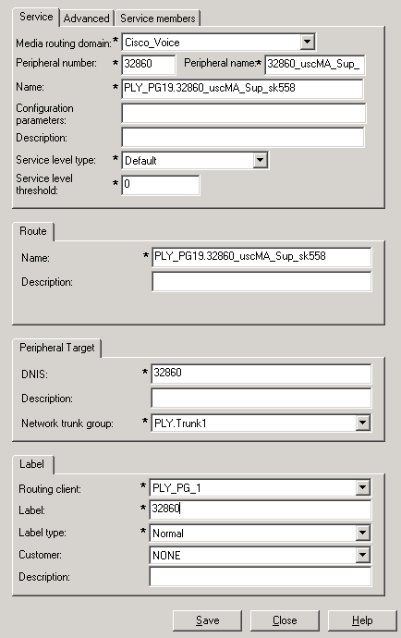

* Select **Save**, the Service is now created in ICM.
* Browse to the file to ensure all details are entered and configuration looks ok.

